**DAILY ONLINE ACTIVITIES SUMMARY**

|  |  |  |  |  |  |  |  |
| --- | --- | --- | --- | --- | --- | --- | --- |
| **Date:** | **16/06/2020** | | | | **Name:** | **Namratha C** | |
| **Sem & Sec** | **8th sem, A sec** | | | | **USN:** | **4AL16CS056** | |
| **Online Test Summary** | | | | | | | |
| **Subject** | | **BDA** | | | | | |
| **Max. Marks** | | **30** | | **Score** | | **24** | |
| **Certification Course Summary** | | | | | | | |
| **Course** | **Introduction to Information Security** | | | | | | |
| **Certificate Provider** | | | **Great Learning** | **Duration** | | | **5hrs** |
| **Coding Challenges** | | | | | | | |
| **Problem Statement: 1)Java Program to calculate Compound Interest** | | | | | | | |
| **Status: Completed** | | | | | | | |
| **Uploaded the report in Github** | | | | **Yes** | | | |
| **If yes Repository name** | | | | **CODES (Namrathasonu)** | | | |
| **Uploaded the report in slack** | | | | **Yes** | | | |

Online Test Details:

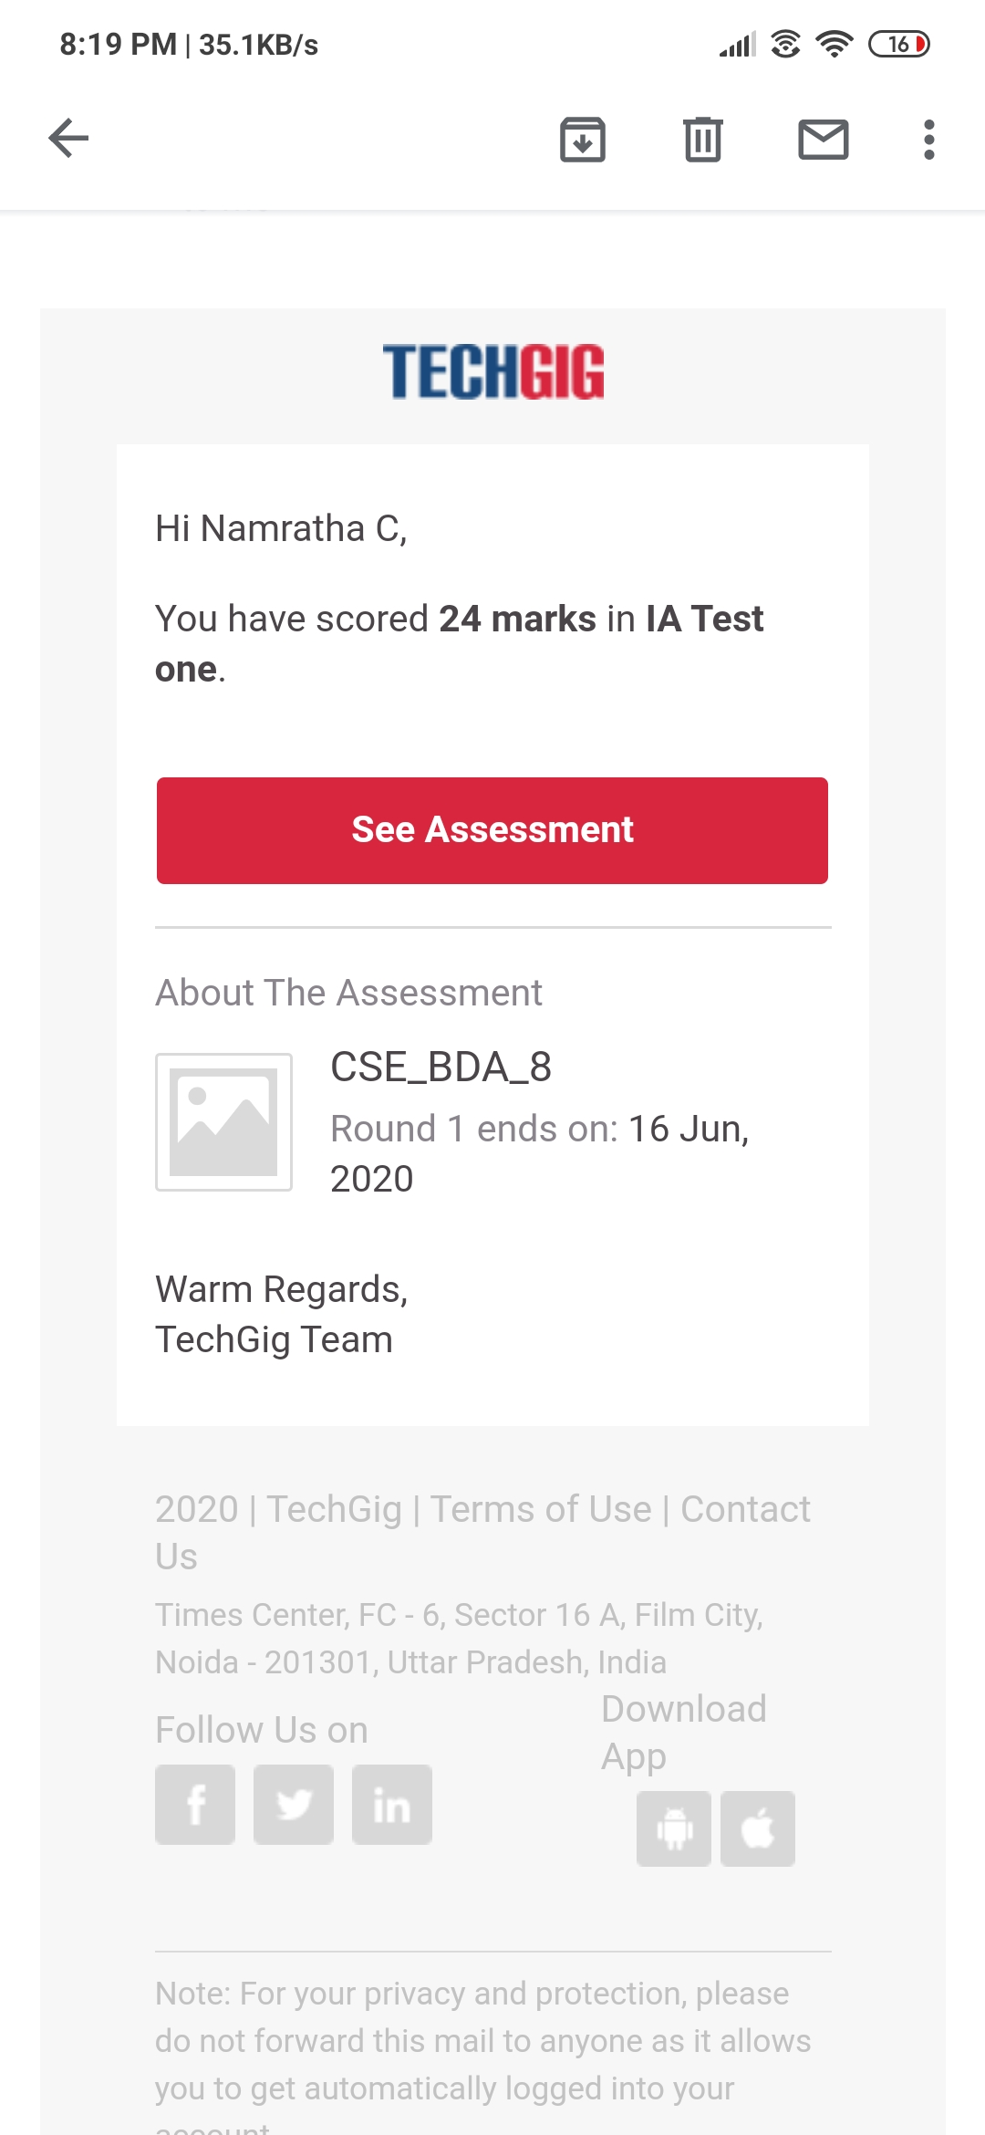

Certification Course Details:

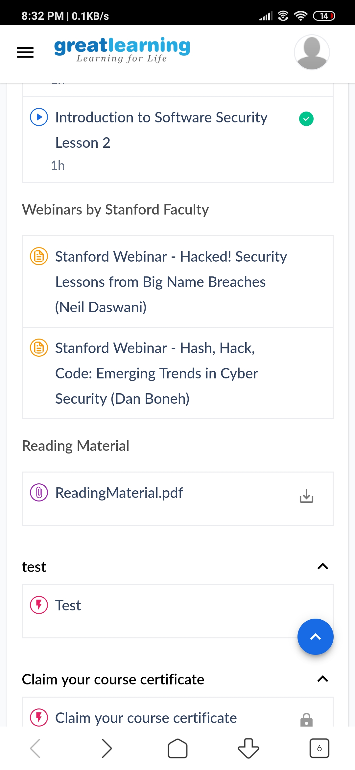

Coding Challenges Details:

1)

public class JavaExample {

public void calculate(int p, int t, double r, int n) {

double amount = p * Math.pow(1 + (r / n), n * t);

double cinterest = amount - p;

System.out.println("Compound Interest after " + t + " years: "+cinterest);

System.out.println("Amount after " + t + " years: "+amount);

}

public static void main(String args[]) {

JavaExample obj = new JavaExample();

obj.calculate(2000, 5, .08, 12);

}

}